

COURSE NAME: Algorithm Analysis

STUDENT: Ertuğrul ŞENTÜRK

HOMEWORK SUBJECT: Calculate the probability that a team with a winning rate of p in a game played by 2 different teams will receive a maximum of n wins in 2n + 1 games.

Algorithm:

1. Necessary win count to win the game and winning ratio inputted from the user.
2. A square matrix has been created with a dimension of 1 more than the number of wins taken to store the winning and losing ratio.
3. First row filled with 1’s for winning value, first column filled with 0’s for losing value.
4. Elements in all remaining indices calculated with:

(winning ratio \* cell above + losing ratio\* cell left) formula.

1. When the entire matrix is ​​filled, the last cell gives our calculated ratio value.

a-) Write the recurrence relation

if(i==0 && j>0) then 1

M[i,j] = else if(i>0 && j==0) then 0

otherwise

M[i-1][j]\*ratio + M[i][j-1]\*(1-ratio)

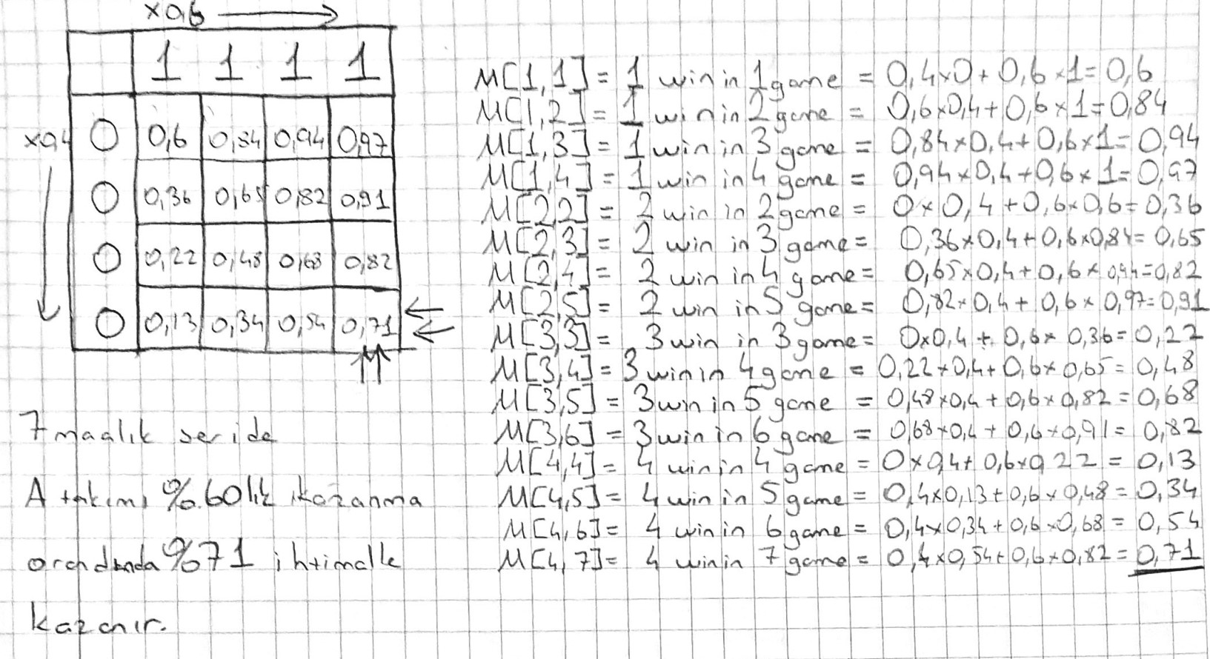b-) Calculate the probability of Team A winning in a series of 7 matches (4 fields win) when the probability of team A winning a match is 0.6.

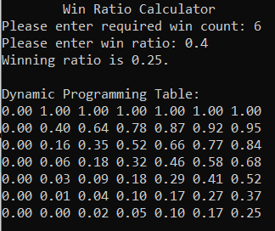Screenshots:

